Hi Maja,

Could you please include in next PMI Sydney Chapter news letter “Critical Path” to be issued in June’13.

PMI Sydney Chapter Toastmasters Club now Chartered

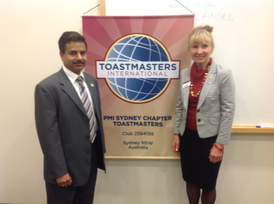
The club was formed on 27th Jul 2012 by initiative of the then Peter O'Driscoll (Vice President’2012 of PMI Sydney Chapter). To get the Club up and running there was a requirement of at least 20 members. The club started with good number of members that grew very quickly to enable the Chartering of the club.
There was a small ceremony held on 1st May where the Charter certificate and the Club banner were presented to the club’s President Puneet Grover by Jan Vecchio DTM District Governor, District 70 official. David Fisher DTM Lt. Governor Marketing, District 70 was also present at this occasion.

The PMI SC Toastmasters club meets every 1st and 3rd Wednesday of the month. For those of you who are not familiar with Toastmasters, and how being part of that organisation will enhance your communication skills take a trip around the Toastmasters web site or visit the District 70 – NSW and ACT – website for more localised information.

